**OTT RATING WEB-APPLICATION**

By

**Deep Golakiya (20BCA077)**

**Javaram Mali (20BCA092)**

**Kunal Sambhavani (20BCA108)**

Under Guidance

of

Internal Guide

**Ms Kritika Pandey**

Submitted to



Smt. Chandaben Mohanbhai Patel Institute of Computer Applications

CHARUSAT

Changa

April-2023



[Accredited with Grade A+ by NAAC,](https://www.charusat.ac.in/)   
                                                                       Accredited with Grade A by KCG

CHAROTAR UNIVERSITY OF SCIENCE & TECHNOLOGY

Changa

**Acknowledgement**

Knowledge in itself is a continuous process.  At this moment of our substantial enhancement, we rarely find words to express our gratitude towards those who were constantly involved with us.

The completion of any inter disciplinary project depends upon coordination, cooperation and combined efforts of several resources of knowledge, creativity, skill, energy and time. The work being accomplished now, we feel our most sincere urge to recall and knowledge through these lines, trying our best to give full credit wherever it deserves.

We would like to thank our project guide **Ms Kritika Pandey** and Dean **Dr. Sanskruti Patel** & principal **Dr. Dharmendra Patel** who advised and gave us moral support through the duration of our project. Without their constant encouragement we could not have been able to achieve what we have.

It’s our good fortune that we had support and well wishes of many. We are thankful to all and those names which have been forgotten to acknowledge here but contributions have not gone unnoticed.

With Sincere Regards,

**Deep Golakiya (20BCA077)**

**Javaram Mali (20BCA092)**

**Kunal Sambhavani (20BCA108)**

# 

|  |  |  |  |
| --- | --- | --- | --- |
| **Sr. No** |  | **Subject** | **Page Number** |
| **1** |  | **Project Profile & Company Profile** | 4 |
| **2** |  | **Introduction to tools** | 6 |
| **3** |  | **System Study** | 9 |
|  |  | Existing System | 10 |
|  |  | Proposed System | 10 |
|  |  | Scope of the Proposed System | 11 |
|  |  | Aim and Objective of the Proposed System | 11 |
|  |  | Feasibility Study | 11 |
|  |  | Operational Feasibility | 13 |
|  |  | Economical Feasibility | 12 |
|  |  | Technical Feasibility | 12 |
| **4** |  | **System Analysis** | 13 |
|  |  | Requirements Specification (along with System Modules) | 14 |
|  |  | Use Case Diagram | 16 |
|  |  | Class Diagram | 17 |
|  |  | Activity Diagram | 18 |
| **5** |  | **System Design** | 19 |
|  |  | Data Dictionary | 20 |
|  |  | Screen Layouts | 26 |
| **6** |  | **System Testing** | 37 |
| **7** |  | **Future Enhancement** | 39 |
| **8** |  | **Bibliography/References** | 41 |

# Project Profile

**Project Profile:-**

**• Project Name:** OTT RATING WEB APPLICATION

**• Type of Application:** Web Application

**• Project Description:** OTT Rating System helps the customers to express their opinion about the various movies and give them flexibility to give their review at their comfort zone(home).

**• Team size: 3**

**• Front End:** php, html, css, javascript.

**• Back End:** MySql

**• Tools used:** Xampp, Bootstrap.

# Introduction to tools

❖**Introduction to Tools**

* **Front End Tool:**• Front End Tool [php]: PHP is called as Hypertext Preprocessor and it is widely used open source general purpose scripting language.
* • PHP is especially suitable for web development and can be easily embedded into HTML.
* • The PHP code is enclosed in special start and end processing instructions that allow you to jump into and out of “PHP Mode”.
* • The best things in using PHP are that it is extremely simple for new programmers, but it offers many advanced features for a professional programmer.
* • PHP’s development is focused on server side scripting, you can do much more with it.
* **Back End Tool[MySql]:**
  + MySQL is an open Source Relational Database Management System. MySQL is written in C and C++.
  + MySQL was created by a Swedish company, MySQL AB, founded by David Axmark, Allan Larsson and Michael Monty Widenius. Original development of MySQL by widenius and Ax mark began in 1994.
* **Features of MySql:** 
  + - Cross-platform support
    - Stored procedures
    - Triggers
    - Cursors
    - Updatable views

System Study

* **System Study**
* **Existing System:-**
  + - * A movie Fan after seeing a particular movie can have the urge to express their views.
      * Due to lack of platforms they are often feel not reachable to mass public.
      * Many Digital platforms have the Youtube channel which provides fake review to their viewers because of the commission they get from the top tier.
      * However, one can visit our website and get the true reviews or even share their reviews of movies or series they’ve watched.
* **Proposed System:-**
  + - Whole Proposed system is online.
    - Following are the users of the system:
      * + User
        + Admin

**User’s Role:**

* + - * + Users can register to the site.
        + User can see web series and movies with full description.
        + They can search the movie according to their wish.
        + User can review the movie.
        + User can delete reset the review made on a particular movie/web series.
        + User can search the movie/we series on the base of genre.
        + They can also message the admin for any other issue.

**Admin’s Role:**

* + - * + Admin can view the list of clients.
        + Admin can View what user have given review.
        + Admin can also view the inquiry from the user who have personally send them.
        + Admin can add movie/web series details and have the authority to change it.
        + Admin can view the words used in the review to analyze the movie/web series.
* **Scope:**
  + Admin can get details and updates very quickly.
  + Less use of Manual work.
* **Aims and Objectives:**
* This Website useful for customer and they can express their views.
* Design a system that is user-friendly and easy to operate.

➢**Feasibility Study:**

## Operational Feasibility:-

User can operate this system very easily, as all things mentioned.

User doesn’t have to wait more. User can get response quickly.

## Technical Feasibility:-

The technical feasibility determines whether the work of the project can be done with the present equipment, current procedures.

## Economical Feasibility:-

As development tools and software are free of cost there is not any burden of buying system. The organization is not having the same system so it is currently required for them.

The profit will be remarkable according to our team. We do not need to invest extra funds to develop the system thus the system is economically feasible to the organization.

System Analysis

## REQUIRMENT SPECIFICATION

1. **Authentication Module**
   * **Register: -** User need to register themselves with their name and can set password.
   * **Login: -** Once registered, User can Log in to the system and can get all the facilities provided by the site.
2. **Browse Product**

User can search the content according to genre.

1. **Review Management**
   * + Content choose by the customer will be able to review.
     + Further, it can be modified.

DIAGRAMs

Usecase diagram

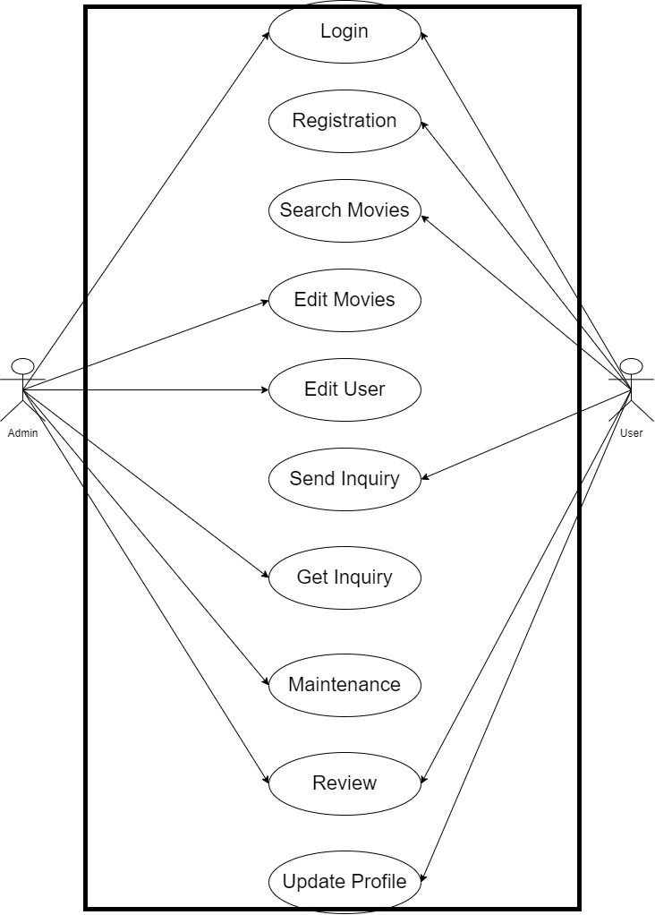

Class diagram

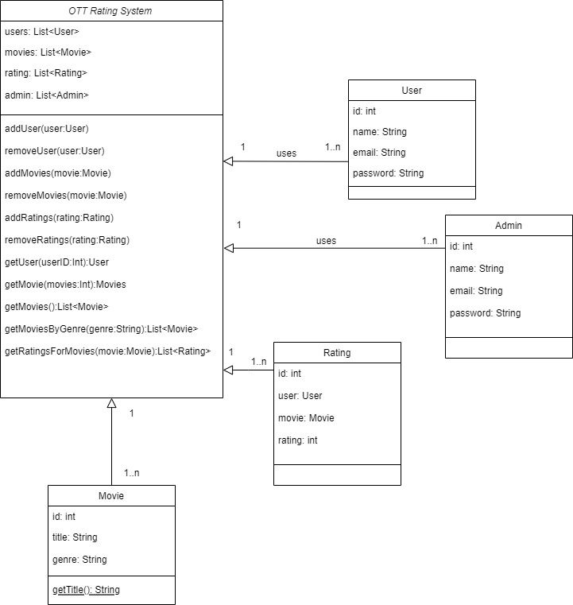

Activity diagram

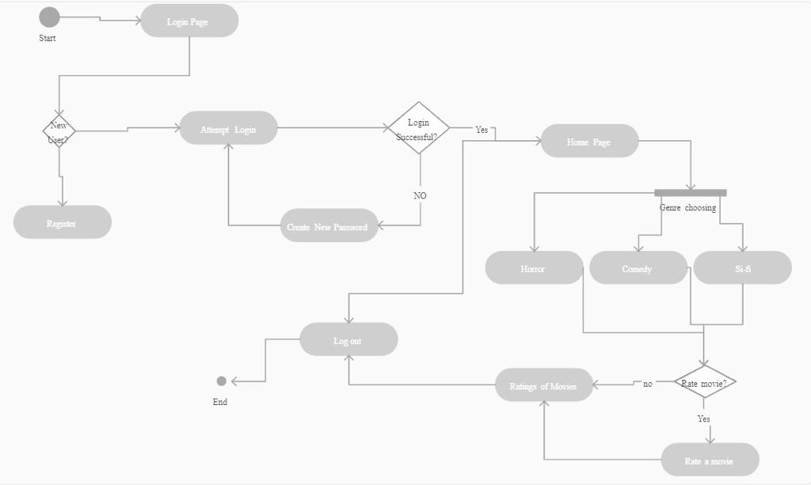

System Design

# Data Dictionary

# CLIENT_TABLE

|  |  |  |  |
| --- | --- | --- | --- |
| COLUMN | TYPE | CONSTRAIN | DESCIPTION |
| ID | INT(50) | PRIMARY KEY | Client id |
| FIRST NAME | VARCHAR | NOT NULL | Client’ first name |
| MIDDLE NAME | VARCHAR | NOT NULL | Client’s middle name |
| LAST NAME | VARCHAR | NOT NULLL | Client’s last name |
| GENDER | VARCHAR | NOT NULLL | Client’s gender |
| EMAIL | VARCHAR | NOT NULLL | Client’s emaillid |
| PASSWORD | TEXT | NOT NULLL | password |
| AVATAR | TEXT | NOT NULLL | Profile picture |
| LAST_LOGIN | DATETIME | NOT NULLL | Last Login time |

GENRE_LIST

|  |  |  |  |
| --- | --- | --- | --- |
| COLUMN | TYPE | CONSTRAIN | DESCRIPTION |
| ID | INT | PRIMARY KEY | GENRE ID |
| NAME | TEXT | NOT NULL | GENRE NAME |
| DATE_CREATED | DATETIME | NOT NULL | CREATING DATE |
| DATE_UPDATED | DATETIME | NOT NULL | UPDATING DATE |

# MESSAGE_LIST

|  |  |  |  |
| --- | --- | --- | --- |
| COLUMN | TYPE | CONSTRAIN | DESCRIPTION |
| ID | INT | PRIMARY KEY | USER ID |
| FULL NAME | TEXT | NOT NULL | NAME OF MESSENDER |
| CONTACT | TEXT | NOT NULL | REASON |
| EMAIL | TEXT | NOT NULL | EMAIL ID |
| MESSAGE | TEXT | NOT NULL | CONTENT |
| STATUS | TINY INT | NOT NULL | 0 OR 1 |

# MOVIE_LIST

|  |  |  |  |
| --- | --- | --- | --- |
| COLUMN | TYPE | CONSTRAIN | DESCRIPTION |
| ID | INT | PRIMARY KEY | MOVIE ID |
| TITLE | TEXT | NOT NULL | TITLE OF MOVIE |
| GENRE | TEXT | NOT NULL | GENRE OF MOVIE |
| DIRECTOR | TEXT | NOT NULL | DIRECTOR OF MOVIE |
| PRODUCER | TEXT | NOT NULL | PRODUCER OF MOVIE |
| WRITER | TEXT | NOT NULL | WRITER OF MOVIE |
| ACTORS | TEXT | NOT NULL | ACTOR OF MOVIE |
| DESCRIPTION | TEXT | NOT NULL | ABOUT MOVIE |
| IMAGE_PATH | TEXT | NOT NULL | PATH OF IMAGE |

# REVIEW_LIST

|  |  |  |  |
| --- | --- | --- | --- |
| COLUMN | TYPE | CONSTRAIN | DESCRIPTION |
| ID | INT | PRIMSRY KEY | REVIEW ID |
| MOVIE_ID | INT | FOREIGN KEY | ID OF MOVIE |
| TITLE | TEXT | NOT NULL | TITLE OF MOVIE |
| COMMENT | TEXT | NOT NULL | CONTENT |
| RATING | FLOAT | NOT NULL | RATINGS OF MOVIUE |
| CLIENT_ID | INT | FOREIGN | CLIENT WHO GAVE RATING |

# SENTIMENT_KEYWORDS

|  |  |  |  |
| --- | --- | --- | --- |
| COLUMN | TYPE | CONSTRAIN | DESCRIPTION |
| ID | INT | PRIMARY KEY | KEYWORD ID |
| KEYWORDS | TEXT | NOT NULL | RATING KEYWORD |
| SCORE | FLOAT | NOT NULL | SCORE OF MOVIE |

# USER

|  |  |  |  |
| --- | --- | --- | --- |
| COLUMN | TYPE | CONSTRAIN | DESCIPTION |
| ID | INT(50) | PRIMARY KEY | Client id |
| FIRST NAME | VARCHAR | NOT NULL | Client’ first name |
| MIDDLE NAME | VARCHAR | NOT NULL | Client’s middle name |
| LAST NAME | VARCHAR | NOT NULLL | Client’s last name |
| GENDER | VARCHAR | NOT NULLL | Client’s gender |
| EMAIL | VARCHAR | NOT NULLL | Client’s emaillid |
| PASSWORD | TEXT | NOT NULLL | password |
| AVATAR | TEXT | NOT NULLL | Profile picture |
| LAST_LOGIN | DATETIME | NOT NULLL | Last Login time |
| TYPE | TINYINT | NOT NULL | USER TYPE |
| STATUS | INT | NOT NULL | 0 OR 1 |
| DATE_ADDED | DATETIME | NOT NULL | ADDING TIME |
| DATE_UPDATED | DATE TIME | NOT NULL | ADDING TIME |

# Screen Layouts

**Login-User**

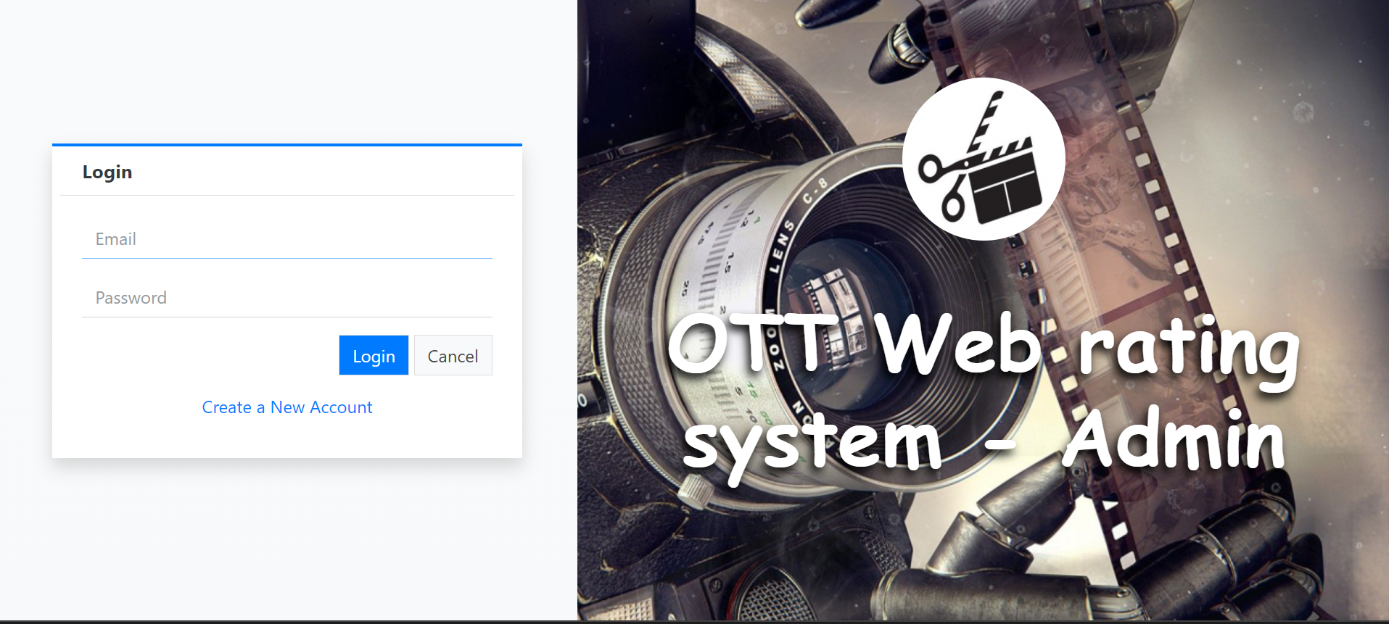

**User Registration**

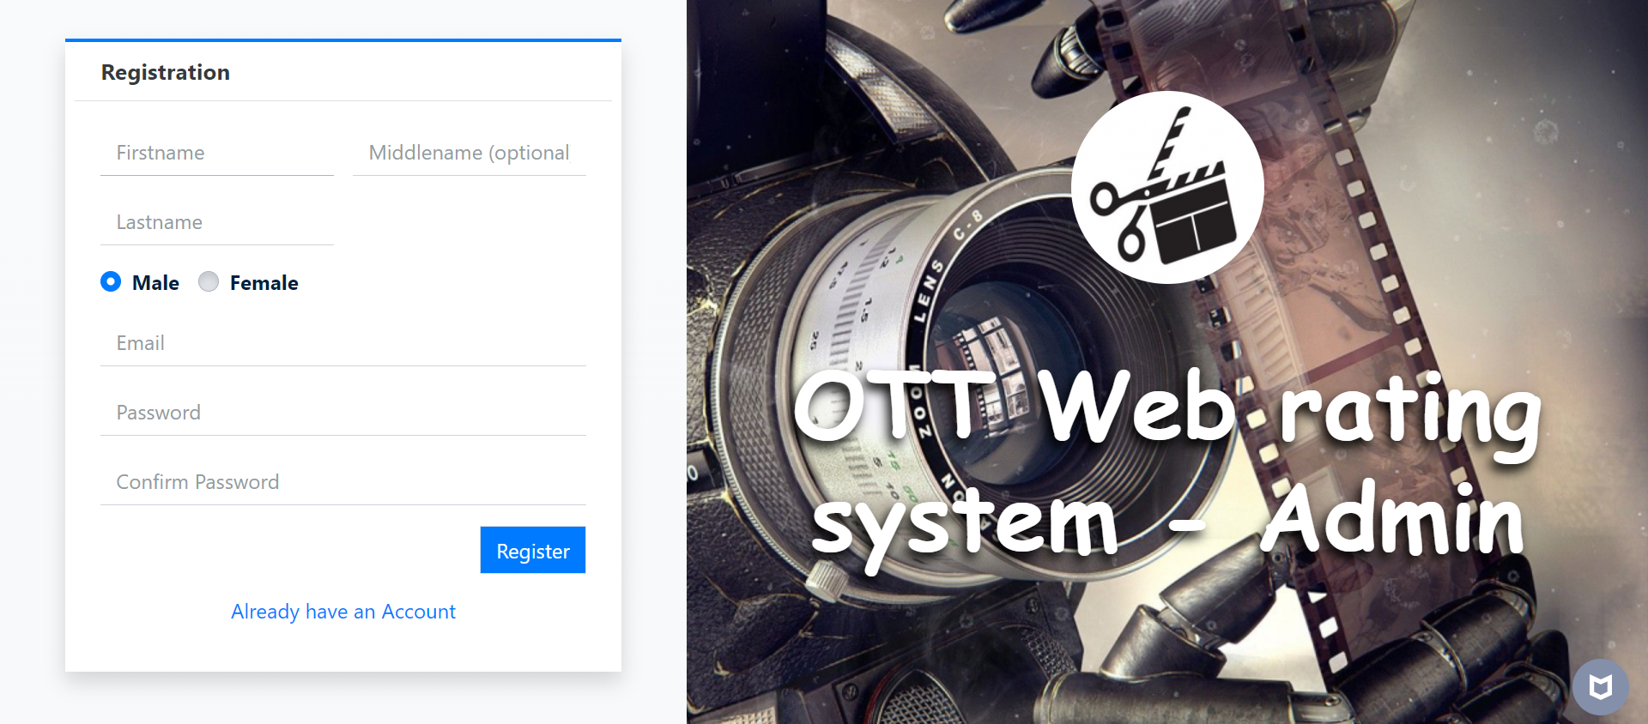

**Home**

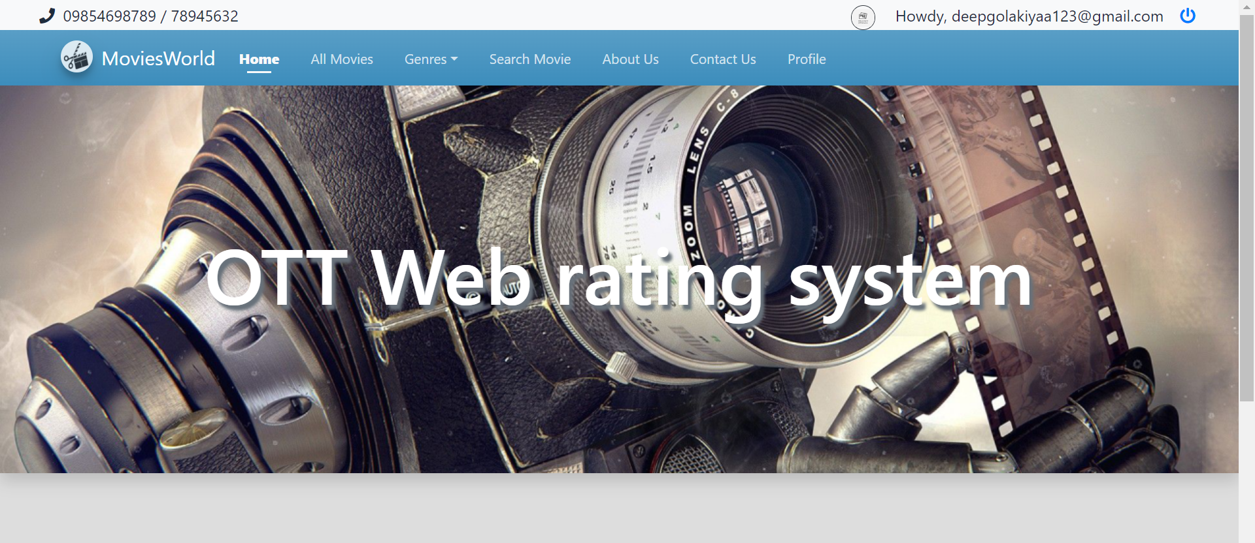

**All Movies**

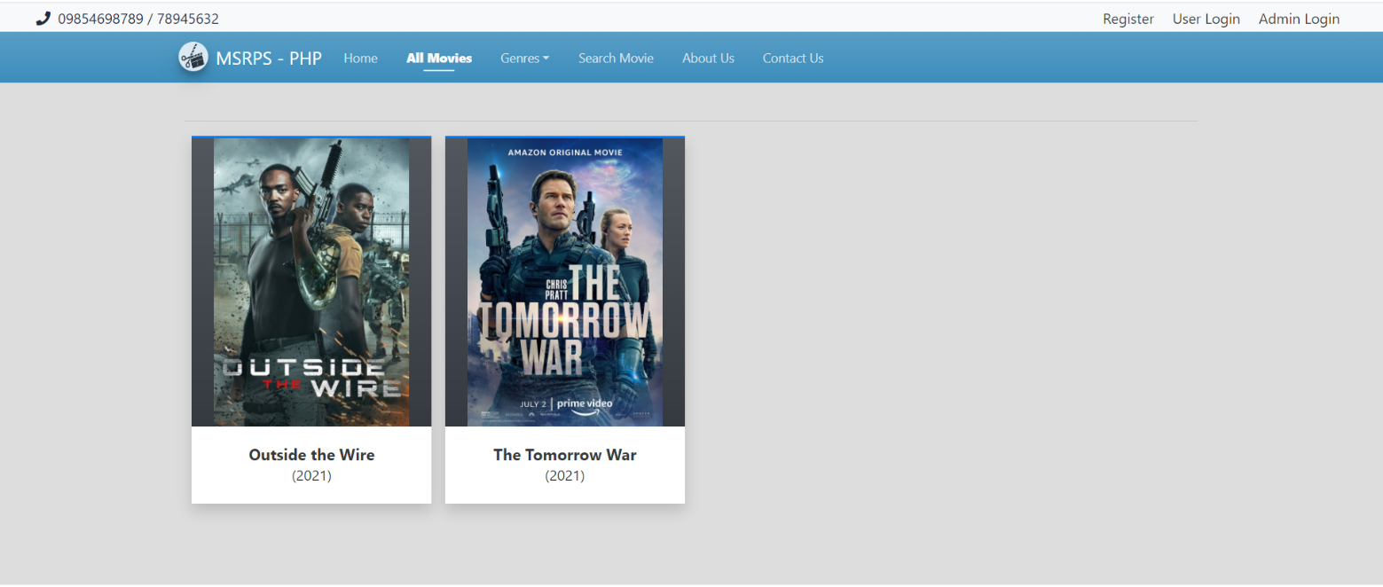

**Review Movie**

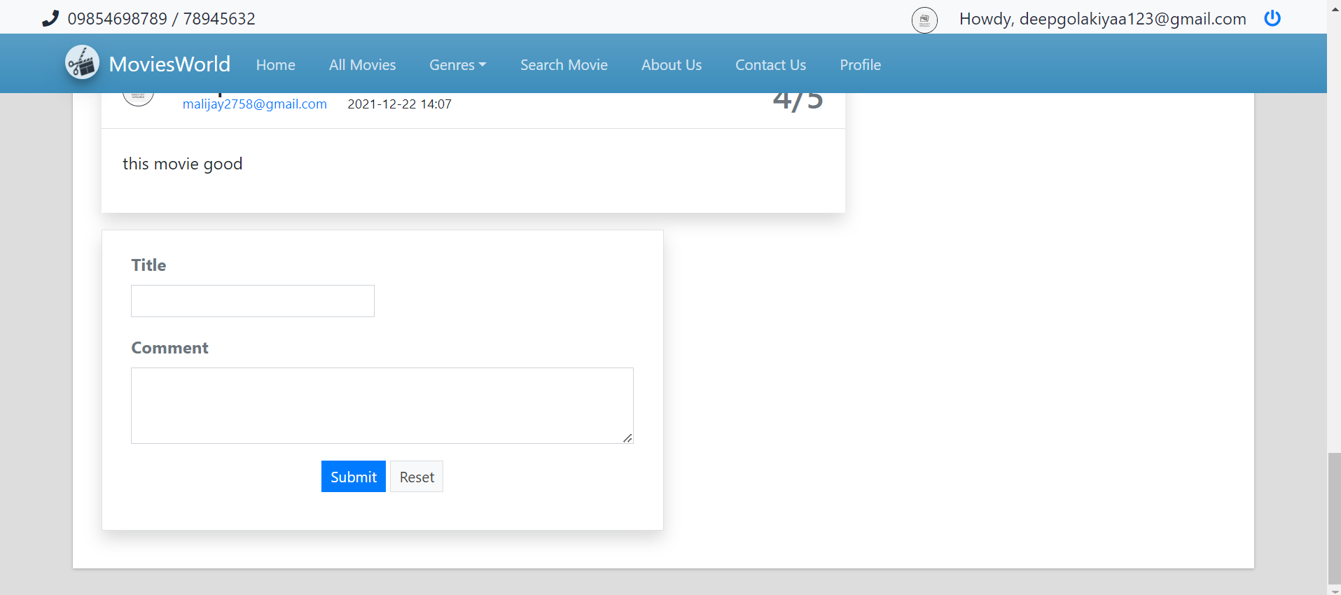

**Search Movie**

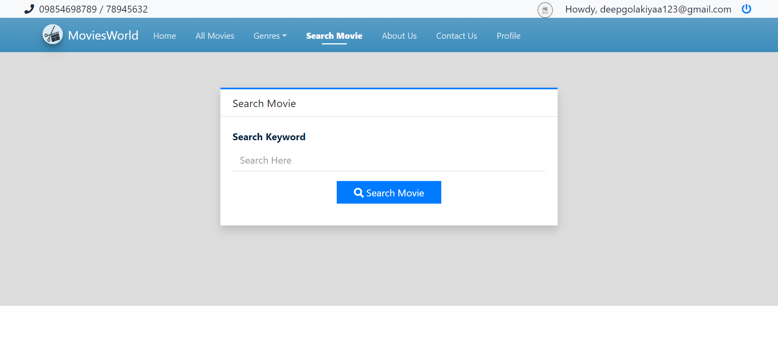

**About Us**

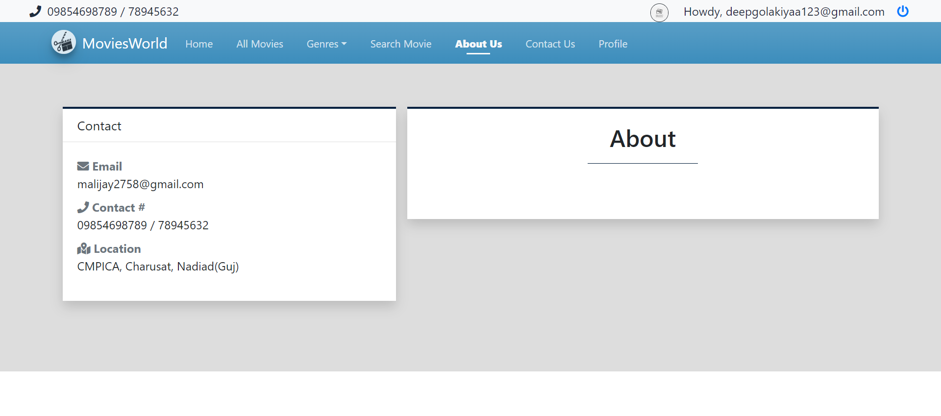

**Contact Us**

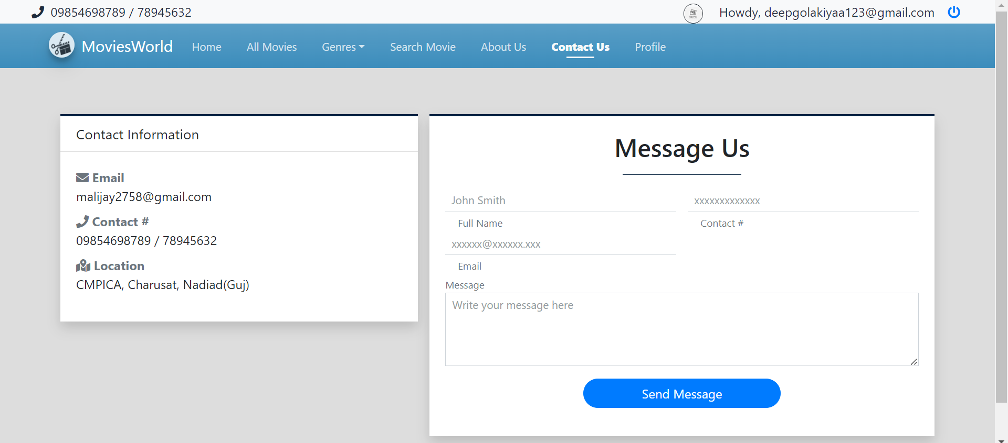

**Sign up for Admin**

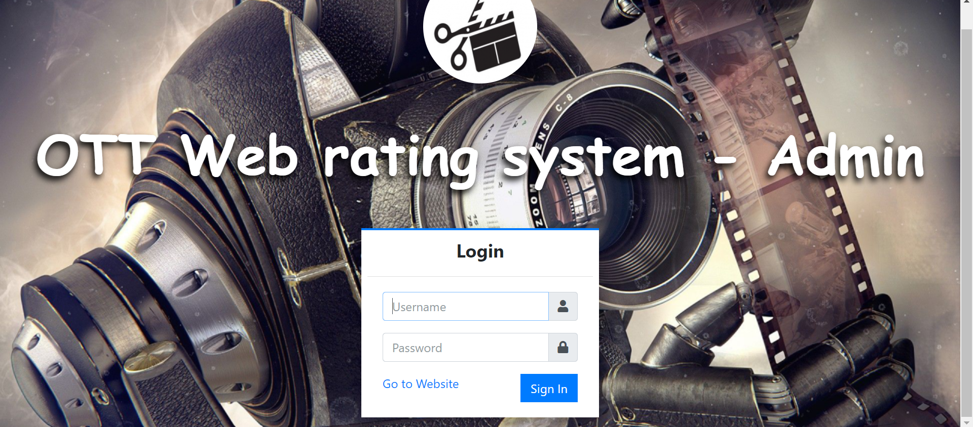

**Home page**

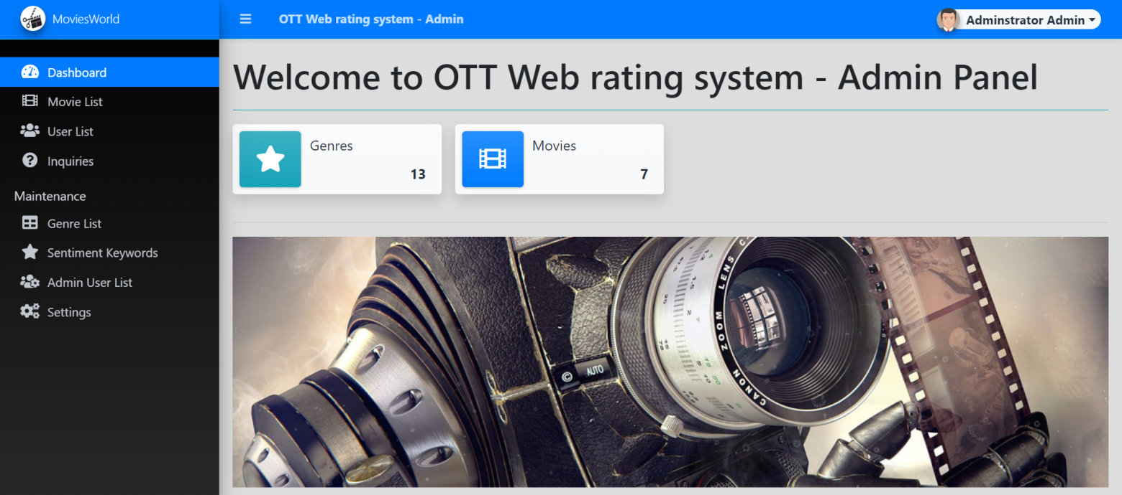

**Movie List**

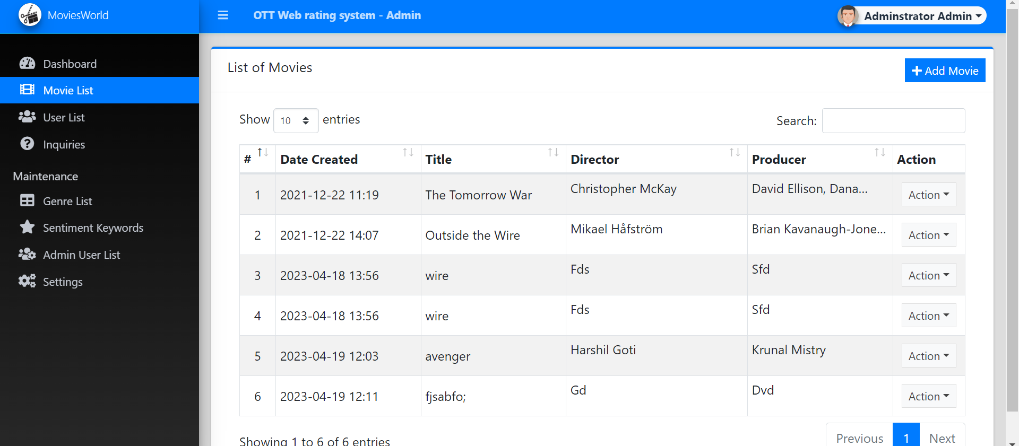

**User List**

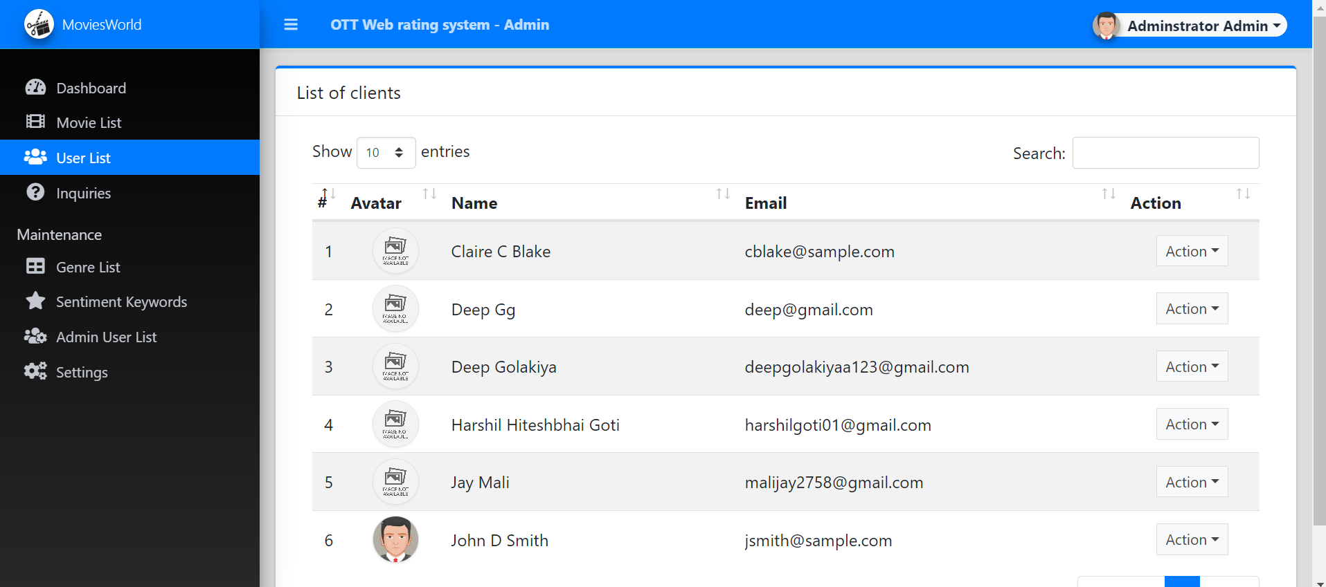

**Inquiries**

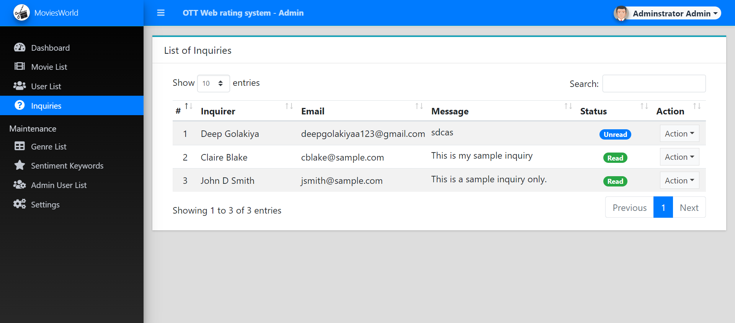

**Genre List**

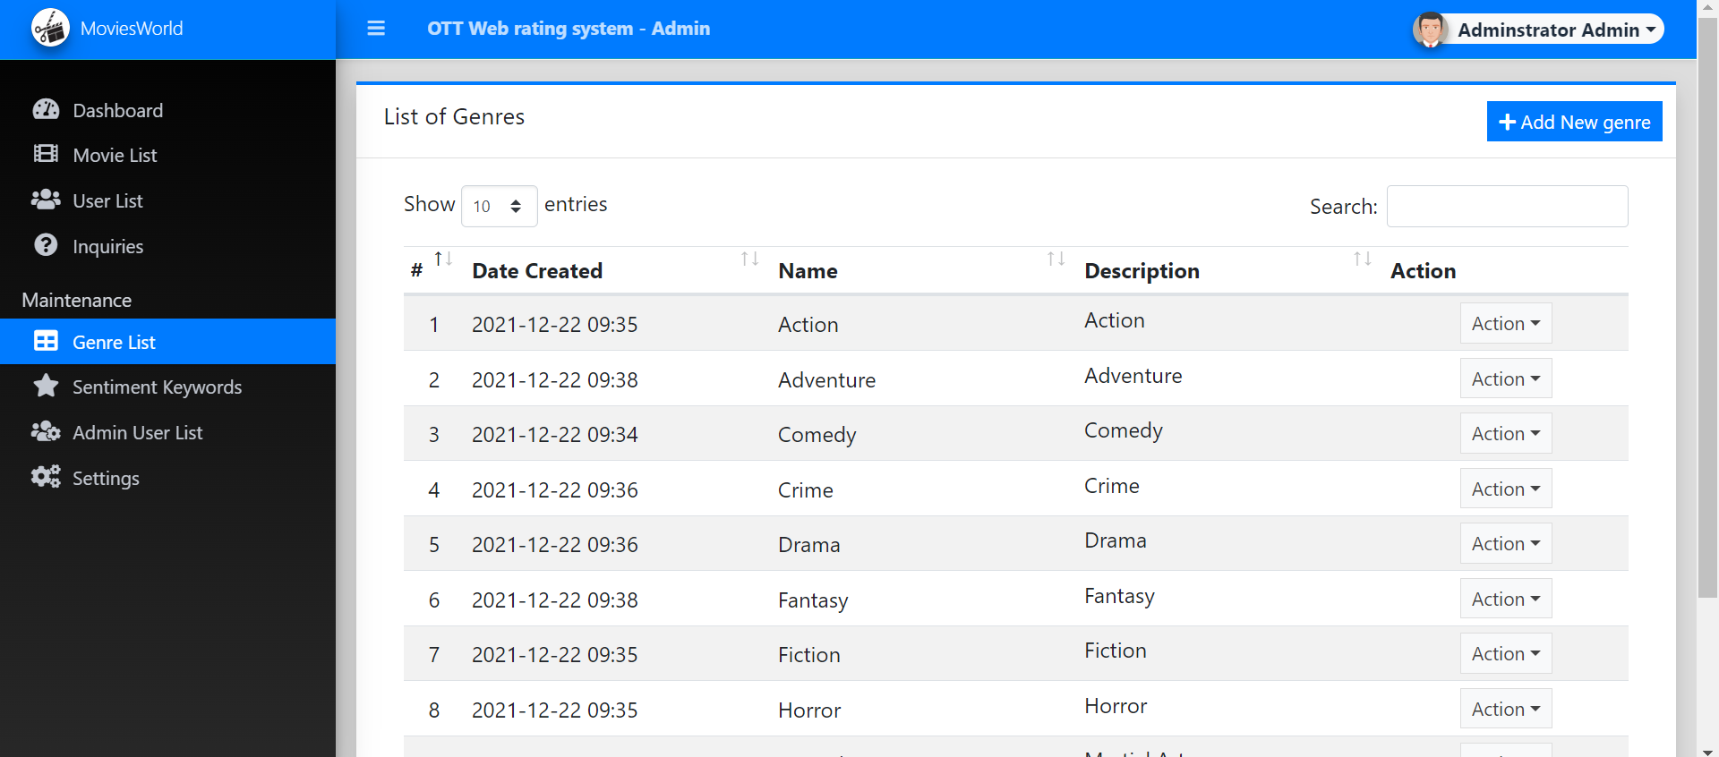

**Sentiment Keywords**

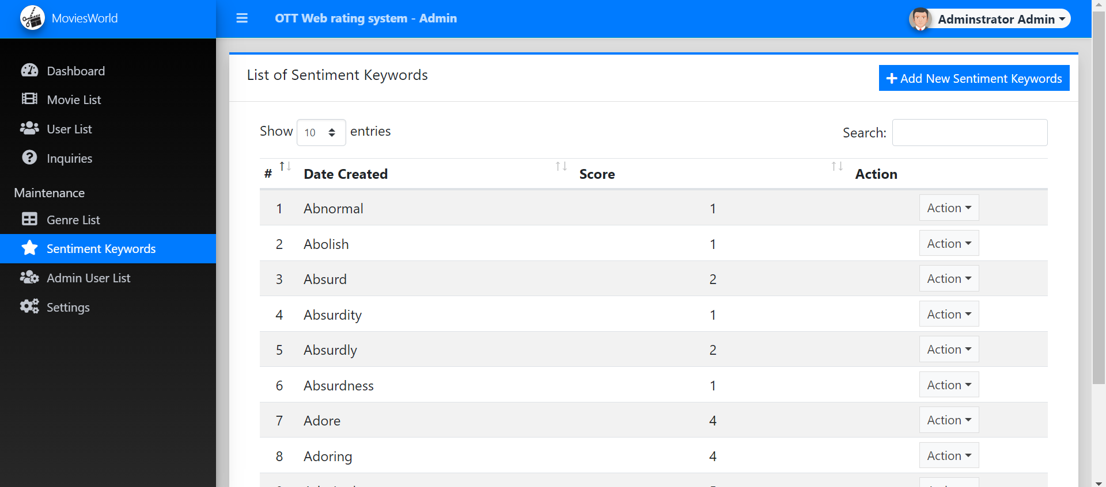

**Admin User List**

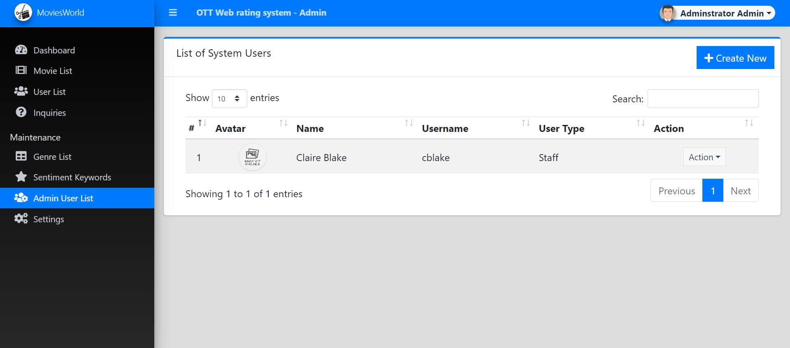

**Settings**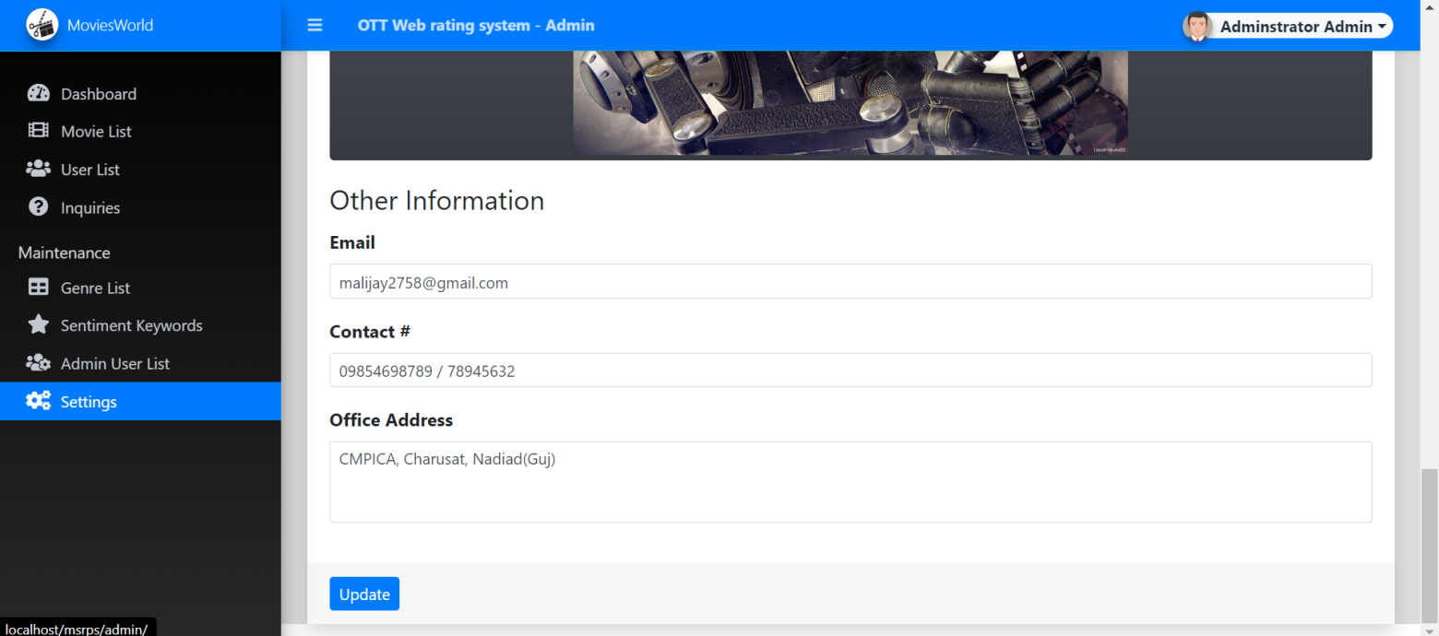

System Testing

|  |  |  |  |  |  |
| --- | --- | --- | --- | --- | --- |
| Sr no | scenario | purpose | input | Output expected | status |
| 1 | login | To login user | Username,password | Login in website | Ok |
| 2 | register | to register | Name,email,password,mobile | Ro get registered | Ok |
| 3 | Rate and review | To rate | ratings | Show review | ok |
| 4 | inquiry | To inquire | Ask the query | Show it to admin | ok |

Future enhancement

**Future Enhancement**

1. To provide a link in the system which direct them to the particular movie trailer.
2. To provide insights from the movie directors and their actors of some undisclosed secrets from the particular movie.

bibliography/

references

1. Took reference from several sites likes w3chools
2. Analysed the imdb system
3. Rating system tutorials from codewithharry

<https://youtu.be/i04U0C-v_to>

<https://www.w3schools.com/howto/howto_css_star_rating.asp>

<https://www.w3schools.com/howto/howto_css_user_rating.asp>

<https://phppot.com/php/php-star-rating-system-with-javascript/>